Name of applicant:
Date of birth:
Contact number:

The Western Cape Communities Co-Existence Agreement defines a Local Aboriginal Person (LAP) as:
- A member of a Traditional Owner Group;
- An Indigenous person connected to a Traditional Owner Group by marriage or adoption; or
- A person recognised as a Local Aboriginal Person by the majority of Indigenous members of the Coordinating Committee who, once the decision is made, will always be a Local Aboriginal Person.
As part of the application process, please select ONLY ONE CATEGORY of the options below:
CATEGORY 1: Need to supply family tree only.
Please attach your Family Tree and select your Traditional Owner Group:
□ I am a Traditional Owner (tick your Traditional Owner Group)
- Alngith | - Anathangayth | - Ankamuthi | - Peppan
- Taepadhighi | - Thanikwithi | - Tjungundji | - Warranggu
- Wathayn | - Wik & Wik Waya | - Yupungathi

CATEGORY 2: Need to select a Traditional Owner Group, provide a family tree and supply a support letter from the Coordinating Committee Traditional Owner Representative (see list of representatives on page 3).
Please select a Traditional Owner Group, provide a family tree and supply a letter of support from a WCCCC Traditional Owner Representative
□ I am a person connected to a Traditional Owner Group by marriage or adoption (tick the Traditional Owner Group
- Alngith | - Anathangayth | - Ankamuthi | - Peppan
- Taepadhighi | - Thanikwithi | - Tjungundji | - Warranggu
- Wathayn | - Wik & Wik Waya | - Yupungathi

CATEGORY 3: Need to supply a family tree and a letter of support from the Local Aboriginal Council of your chosen local community.
Please select your local community, provide a family tree and letter of support with confirmation that you have lived in community for an extended period of time from one of the local councils listed below.
□ I am a person recognised as a Local Aboriginal Person by a majority of Indigenous Members of the Coordinating Committee who, once the decision is made, will always be a Local Aboriginal Person.
Please select which community you are from:
- Napranum | - Mapoon
- Aurukun | - New Mapoon

FATHERS FAMILY TREE
MOTHERS FAMILY TREE
Applicants Partners Name
__________________________________

___________________________________
Traditional Owner Group
Applicants Name
__________________________________

___________________________________
Traditional Owner Group
Fathers Name
__________________________________

___________________________________
Traditional Owner Group
Mothers Name
__________________________________

___________________________________
Traditional Owner Group
Grandmothers Name
______________________

______________________
Traditional Owner Group
Grandfathers Name
______________________

______________________
Traditional Owner Group
Grandmothers Name
______________________

______________________
Traditional Owner Group
Grandfathers Name
______________________

______________________
Traditional Owner Group
Great Grandfathers Name
______________________

______________________
Traditional Owner Group
Great Grandmothers Name
______________________

______________________
Traditional Owner Group
Great Grandfathers Name
______________________

______________________
Traditional Owner Group
Great Grandmothers Name
______________________

______________________
Traditional Owner Group

Coordinating Committee Members | Traditional Owner Group
COLLEEN JOHN | ALNGITH
ERNEST SNR MADUA | ALNGITH
LEANNE GORDON | ANATHANGAYTH
MAURICE WOODLEY | ANATHANGAYTH
BRUCE GIBSON | ANKAMUTHI
TRACEY LUDWICK | ANKAMUTHI
MELANIE WILSON | PEPPAN
MARIE PITT | PEPPAN
ALBERT BOND | TAEPADHIGHI
JULIE MAIRU | TAEPADHIGHI
ANNA MOTTON | THANIKWITHI
CORINE MATASIA | THANIKWITHI
GERALDINE YORK | TJUNGUNDJI
GERALDINE MAMOOSE | TJUNGUNDJI
DELORIA NIXON | WARRANGGU
PATRICIA MARK | WARRANGGU
JIMMY COCONUT | WATHAYN
LORRAINE COCONUT | WATHAYN
LOYLA CHEVATHEN | WIK-WAYA
RHONDA WOOLLA | WIK-WAYA
MICHELLE KOSTECKI | YUPUNGATHI
CONSTANCE PORT | YUPUNGATHI
Honorary Members | Traditional Owner Group
CHARLES WOOSUP | ANKAMUTHI
MARYANN COCONUT | THANIKWITHI
LILY YORK | WARRANGGU
EDNA MARK | WARRANGGU
BEATRICE GORDON | WATHAYN
CELIA FLETCHER | TAEPADHIGHI

IMPORTANT PLEASE READ

Rio Tinto Weipa and the WCCCC will not accept this form if it is completed incorrectly.

Applicants CANNOT ask WCCCA Coordinating Committee Members to sign off your LAP Status Form. All Local Aboriginal Person (LAP) – Status Forms will be placed before the Coordinating Committee Meeting for final endorsement.

Please include any other information you would like to include that may support your request for Local Aboriginal Person (LAP) Status. Please attach additional paper if required.

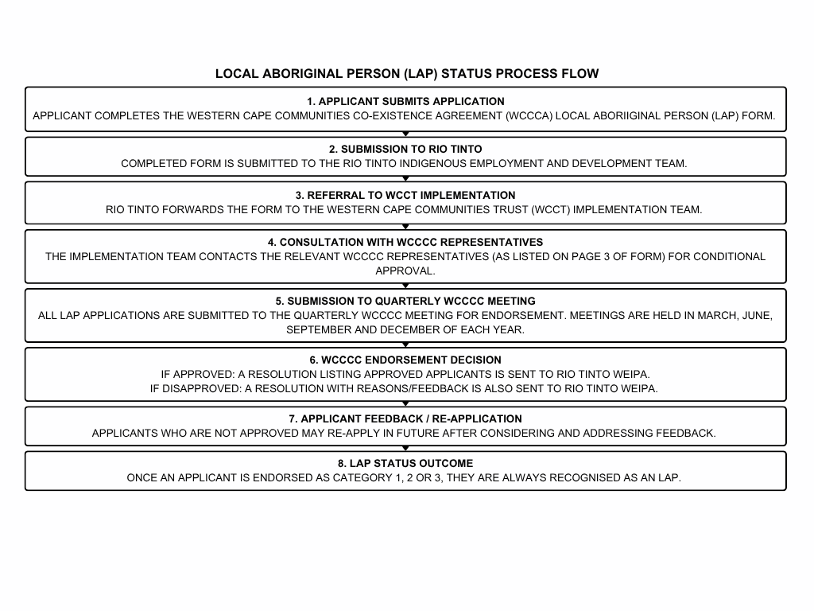

Consent to use personal information:
I hereby provide permission for you to collect and use the personal and cultural information in this form, such as my name, family tree, Traditional Owner Group, and community connection, to help confirm my status as a Local Aboriginal Person (LAP).

This information will only be used for:
- Assessing and confirming LAP status through the WCCCA process; and
- Supporting local indigenous employment records and reporting by Rio Tinto for the WCCCA.

I understand that I can ask to see or update my information at any time by contacting the Western Cape Communities Trust or Rio Tinto Weipa.

By signing below, I agree that I understand and accept how my information will be used.

Name:
Signature:
Date:

For Office Use Only:
Coordinating Committee Rep:
LAP Status: | Approved: | Yes □ | No □ | Dated:
Comments:
Coordinating Committee Rep:
LAP Status: | Approved: | Yes □ | No □ | Dated:
Comments:

